**Module-3: Alarms Assignment 5**

**Problem Statement**

You work for XYZ corporation, to maintain the security of the AWS Account and the resources you have been asked to implement a solution, that can easily help recognize and monitor the different users. Also, you will be monitoring the machines created by these users for any errors or misconfigurations.

**You have been asked to**

1. Create a CloudWatch Billing Alarm which goes off when the estimated charges go above 500$.
2. Create a CloudWatch Alarm which goes off to an Alarm state when the CPU utilization of an EC2 instance goes above 65%.
3. Also add an SNS topic, so it notifies the person when the threshold is crossed.

**Problem Solution 1:** Create a CloudWatch Billing Alarm which goes off when the estimated charges go above 500$.

***Note: CloudWatch Billing Alarm is only accessed through North Virginia Region Only. Here, we will create the Billing Alarm from North-Virginia Region in AWS.***

**Step 1: Choose** the **“US East (N.Virginia)”** inthe **“AWS Console”.**

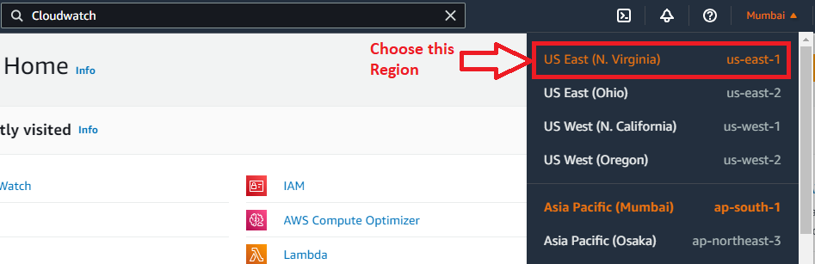

**Step 2:** In the “**Service”** section, search the “**Cloudwatch”** & **click** on the “**Alarms”**.

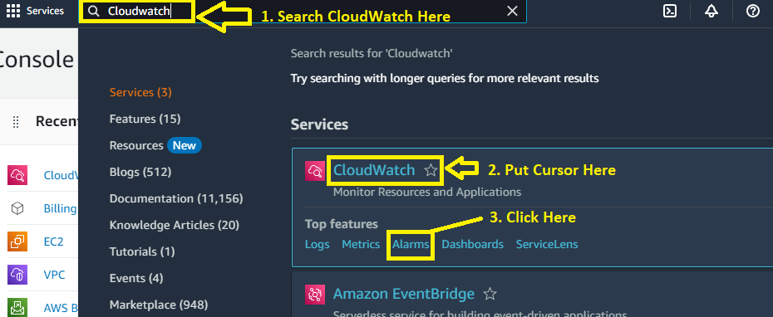

**Step 3: Click** onthe **“Create Alarms”.**

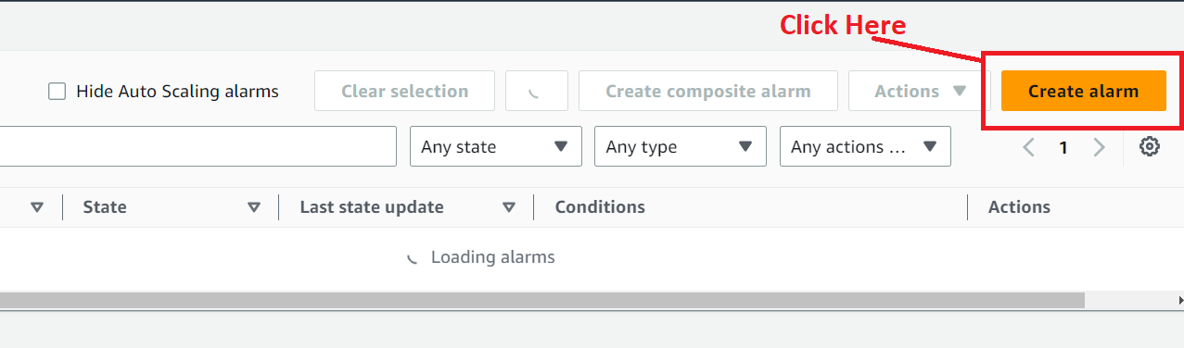

**Step 4: Choose** the **“Select Metric”** option.

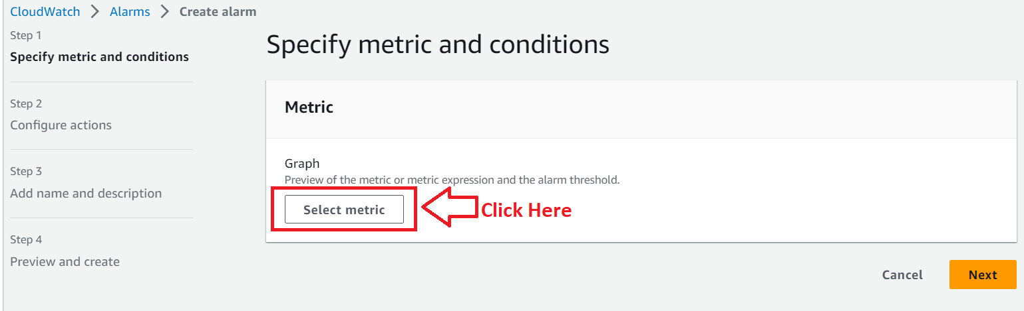

**Step 5: Click** onthe **“Billing”** option.

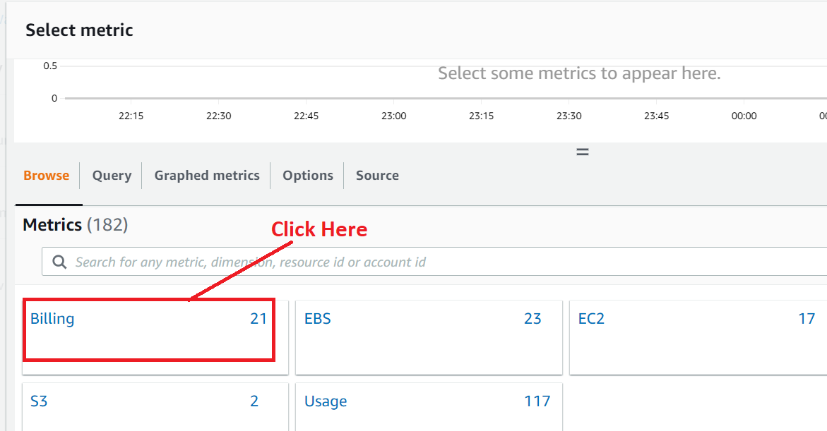

**Step 6: Click** onthe **“Total Estimated Charge”.**

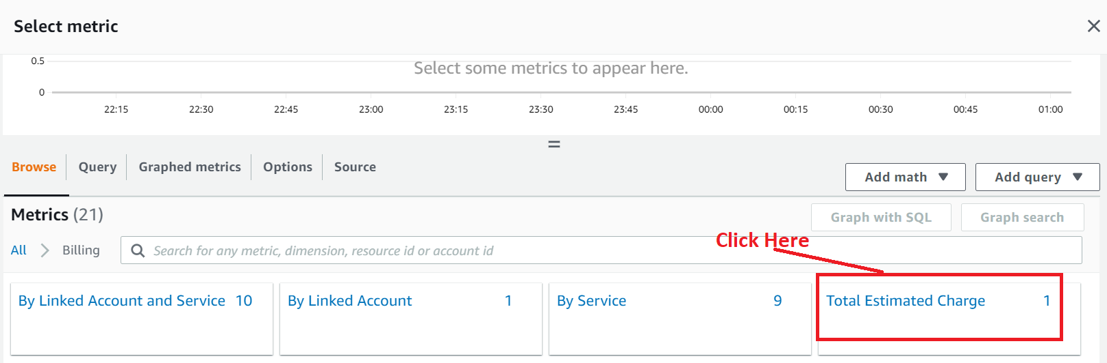

**Step 7: Choose** the **“Currency”** as **“USD”** & **click** onthe **“Select metric”** button.

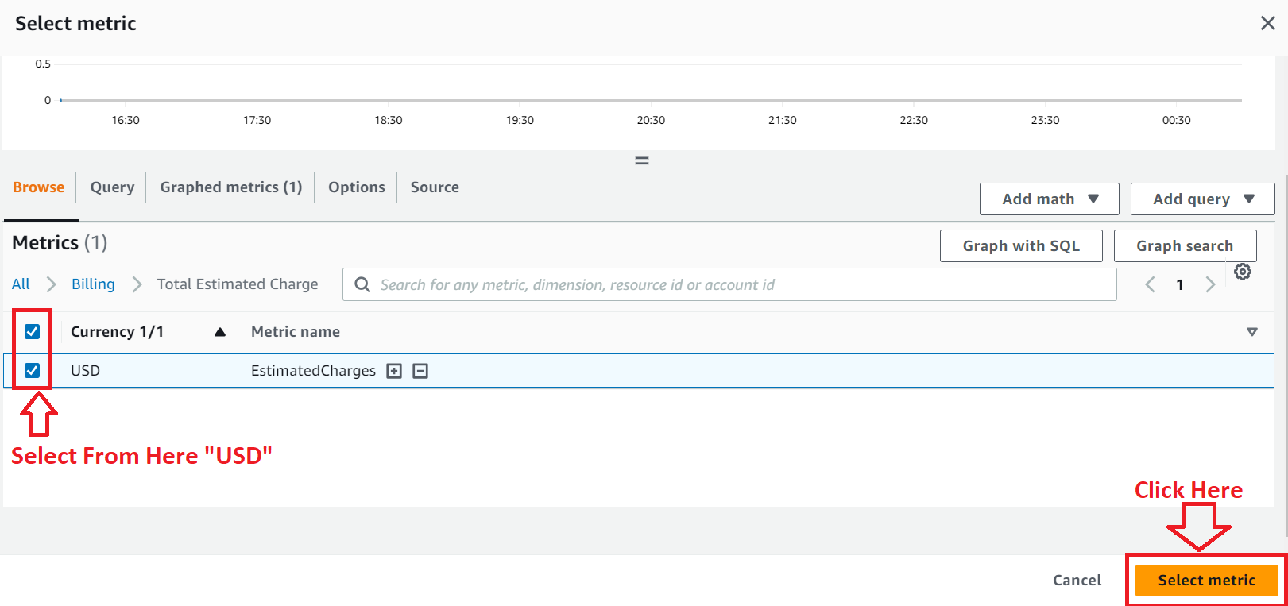

**Step 8: In** the **“Condition”, choose** the **“Estimated Charges”** is **greater than “500 USD”.**

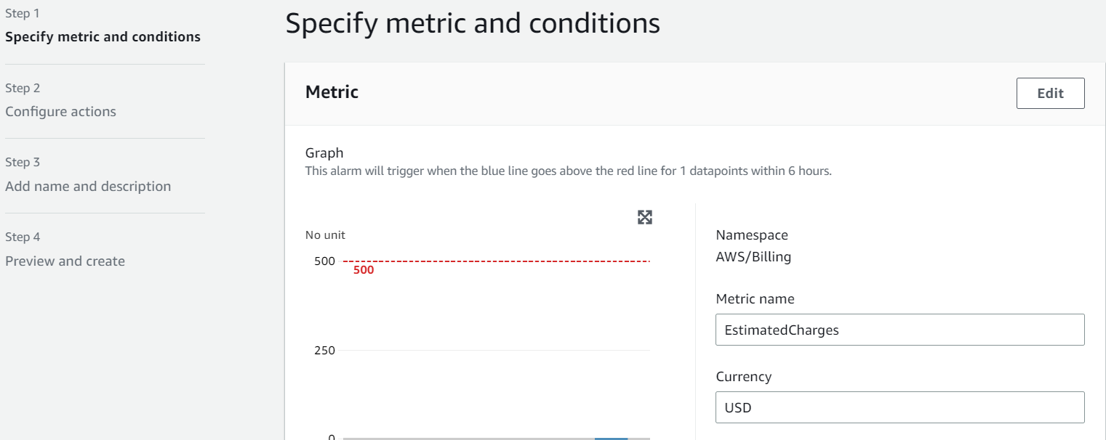

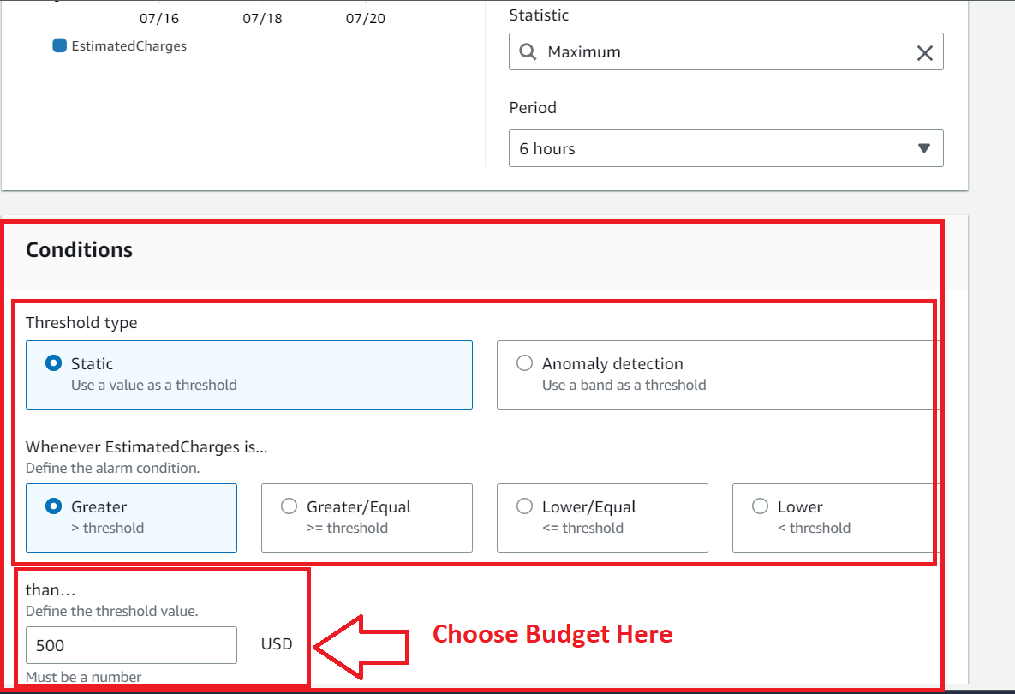

**Step 9: Click** onthe **“Next”.**

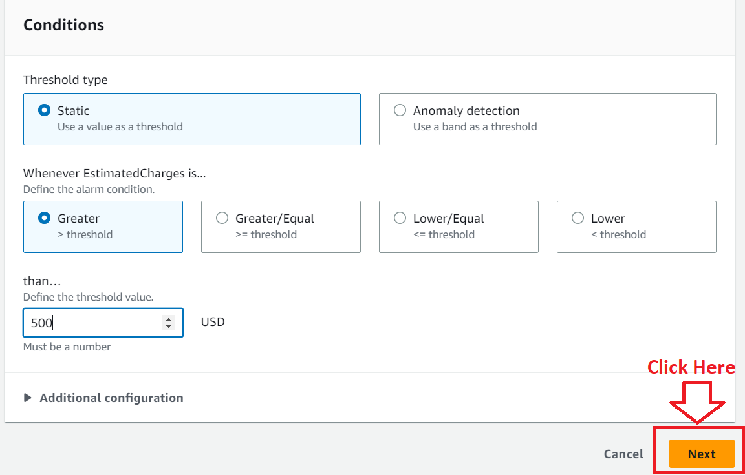

**Step 10: In** the **“Configure actions”, no need** to **do any settings, click** onthe **“Next”.**

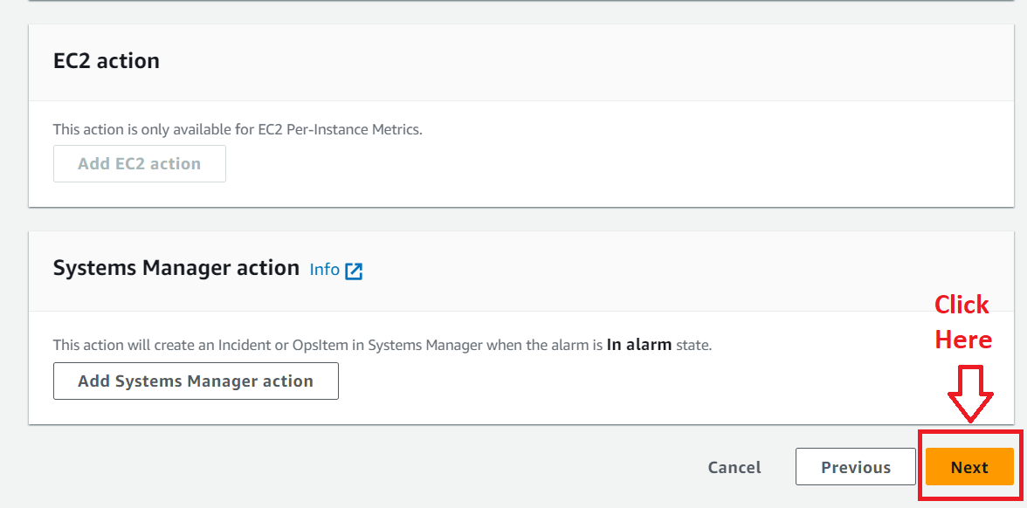

**Step 11: Choose Alarm Name** asthe **“Cloudwatch_billing” & click** onthe **“Next”.**

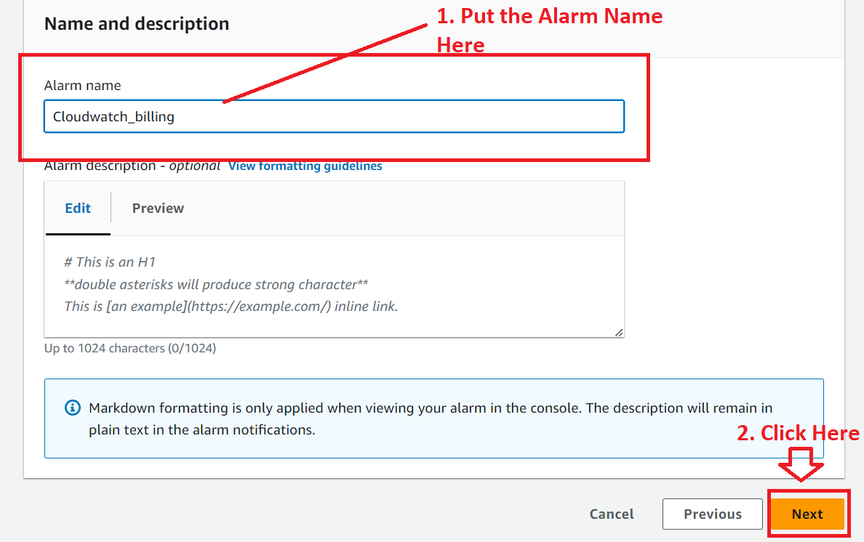

**Step 12: Click** onthe **“Create alarm”.**

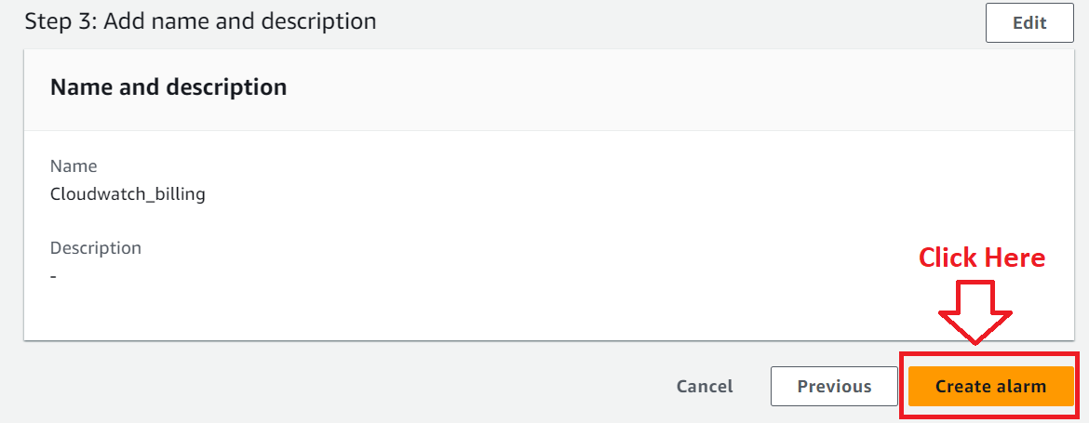

**Step 13: Your “Billing Alarm”** of **“500 USD”** has been **successfully created.**

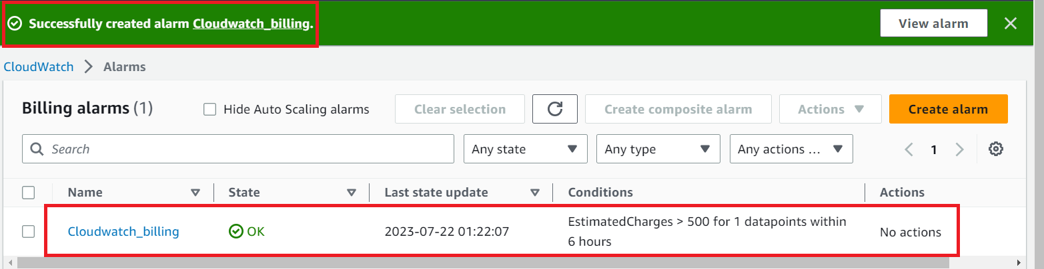

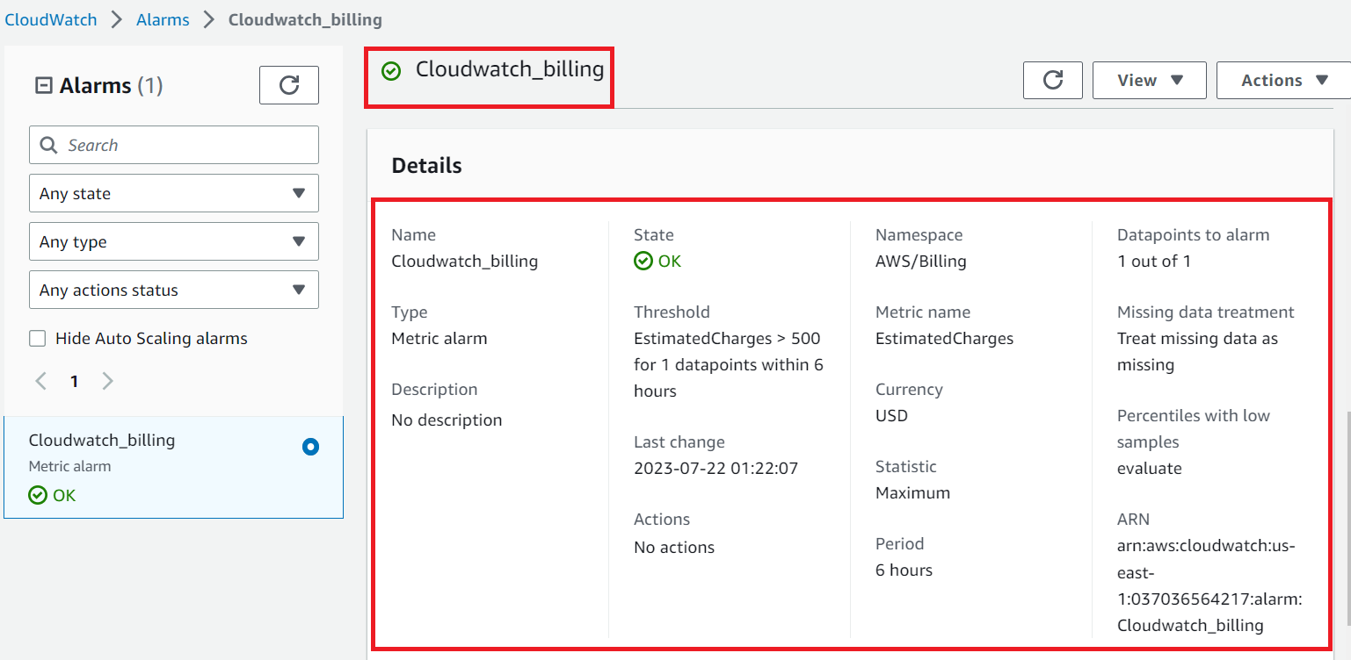

**Problem Solution 2:** Create a CloudWatch Alarm which goes off to an Alarm state when the CPU utilization of an EC2 instance goes above 65%.

**Step 1: First, we** will **create** an **EC2 Instance. Go** tothe **“Amazon Console>EC2”.**

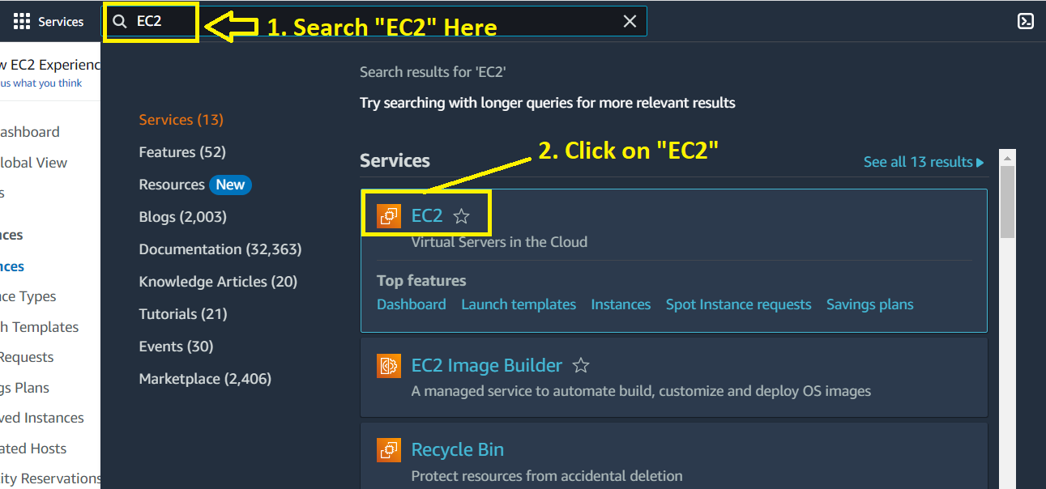

**Step 2: Click** on the **“Launch Instance”.**

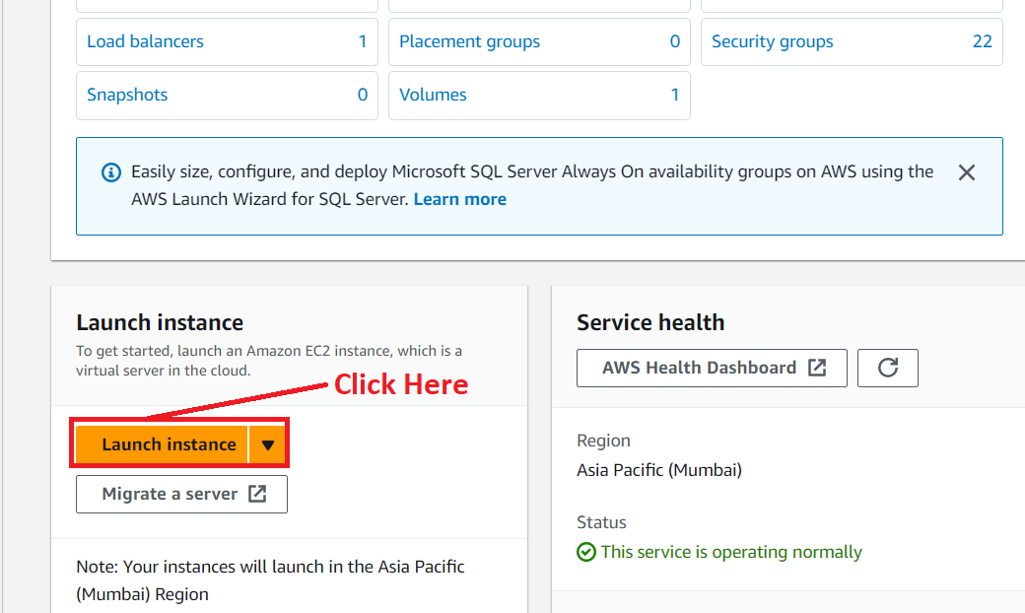

**Step 3: In** the **“Name & Tags” section, put** the **EC2 Instance Name** as the **“EC2_Cloudwatch”.**

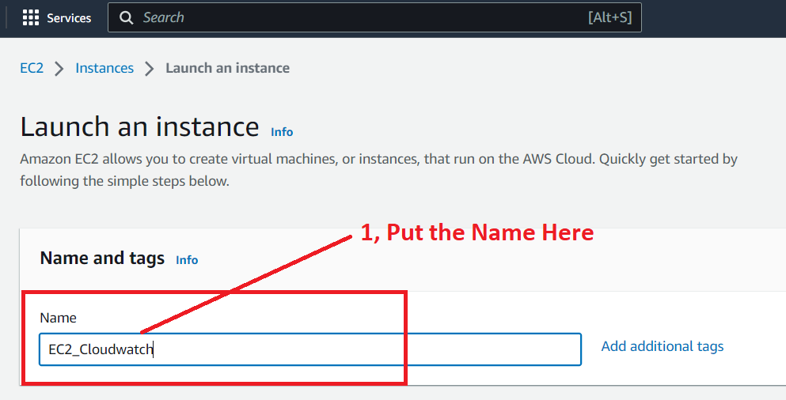

**Step 4: Choose** the **“AMI”** as **“Amazon Linux 2023 AMI”.**

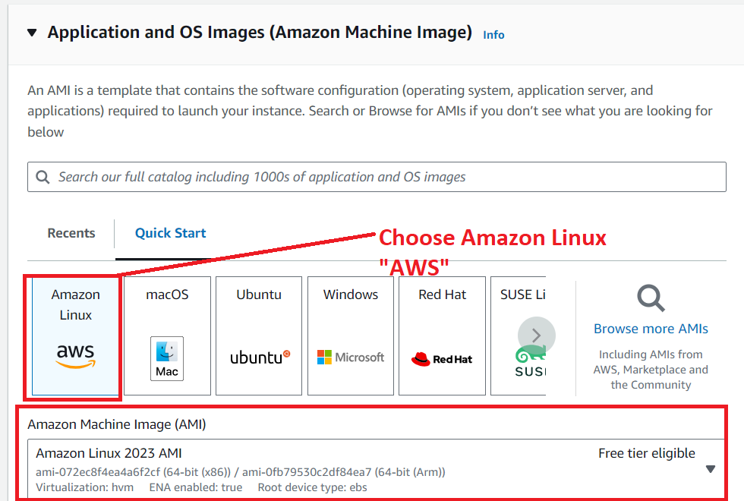

**Step 5: Choose** the **“Instance Type”** asthe **“t2.micro” &** the **“Key pair”** as **“Proceed without a key pair (Not recommended).**

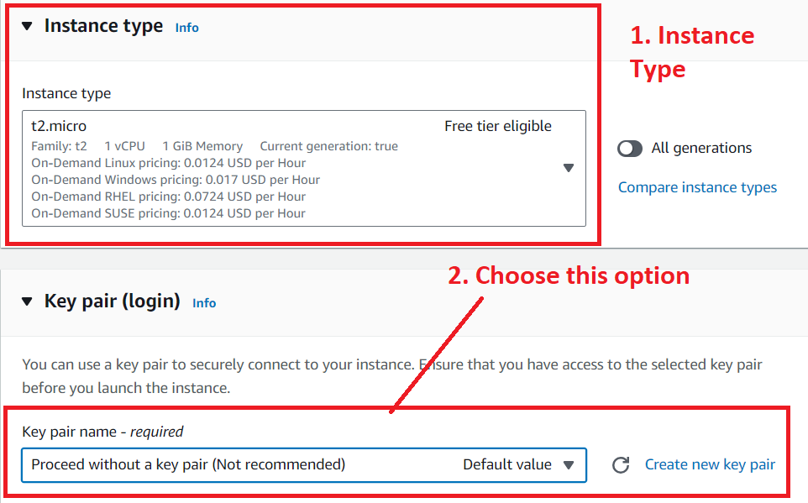

**Step 6: Choose** the **“Allow HTTP traffic from the internet”** inthe **“Network Settings”. Remain** the **other settings** by **default** as **it is. Click** on the **“Launch Instance”.**

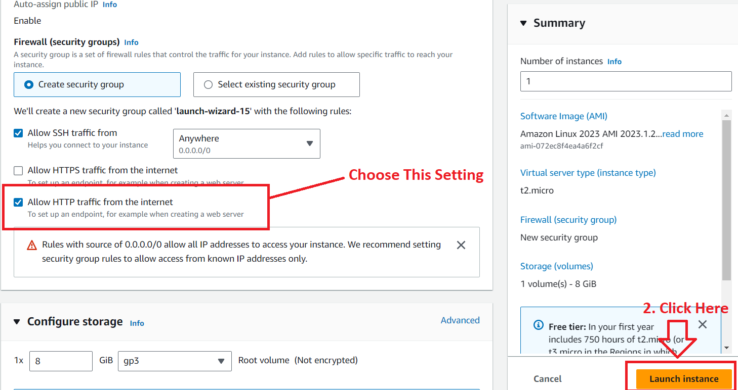

**Step 7: Your EC2 Instance** will be **successfully launched.**

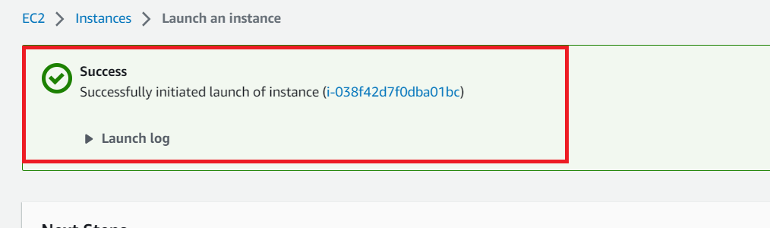

**Step 8: Click** on the **blue hyperlink (**[i-038f42d7f0dba01bc](https://ap-south-1.console.aws.amazon.com/ec2/home?region=ap-south-1#Instances:instanceId=i-038f42d7f0dba01bc)) to **view** your **EC2 Instance.**

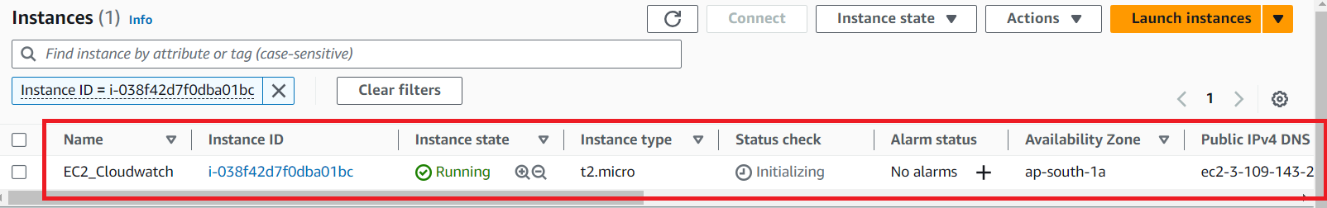

**Step 9: Search** the **“Cloudwatch”** inthe **“Services”** section**. Go** tothe **“Cloudwatch>Alarms”.**

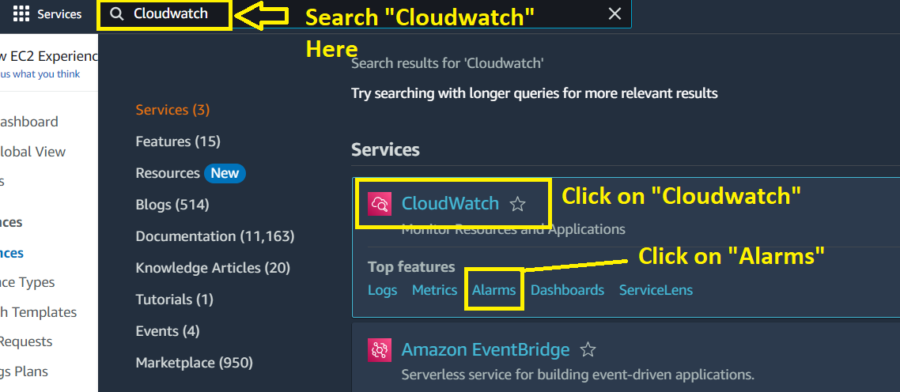

**Step 10: Click** onthe **“Create alarm”.**

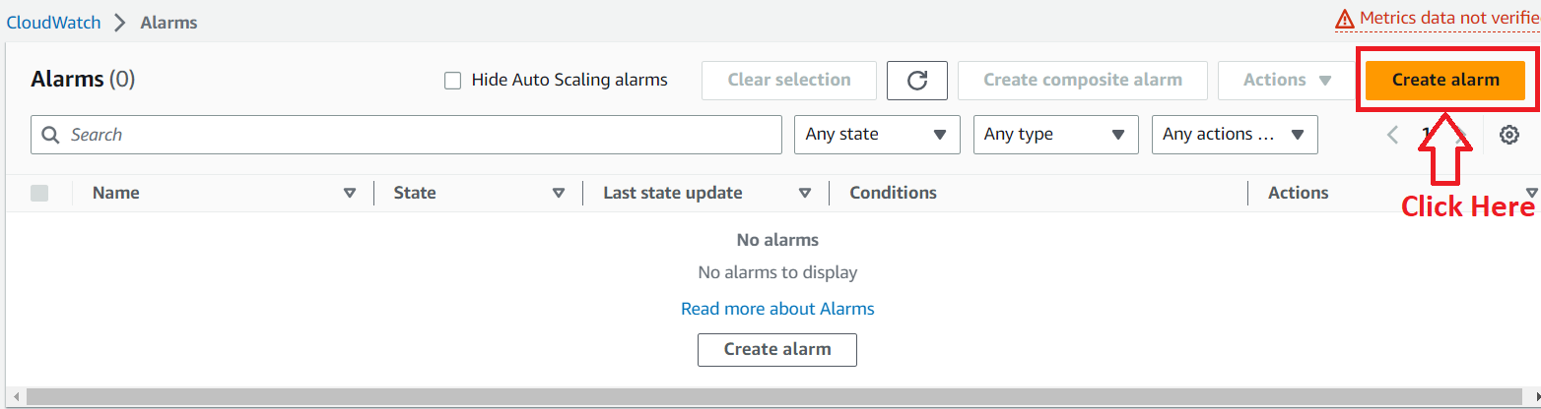

**Step 11: Choose** the **“Select metric”** option.

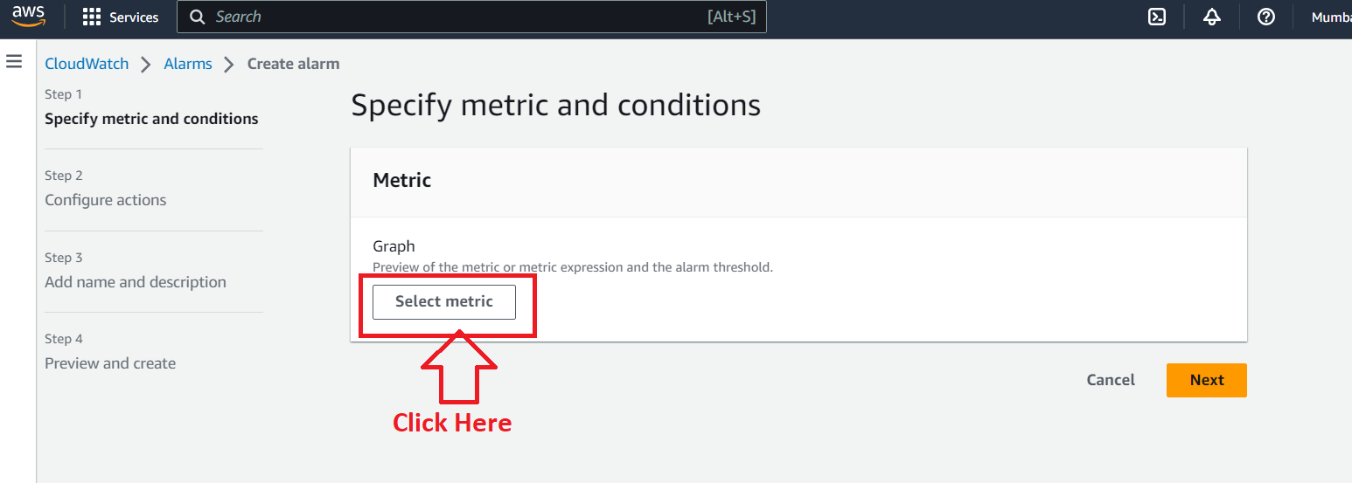

**Step 12: Choose** the **“EC2”** here.

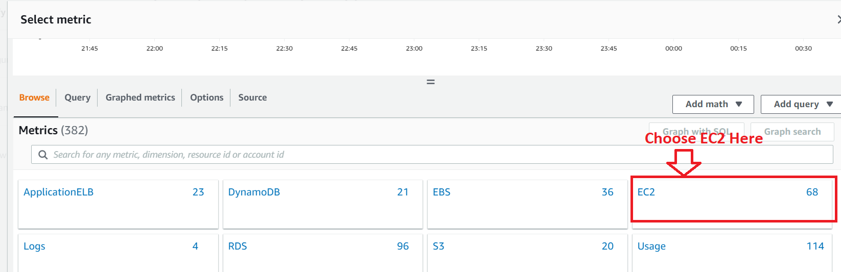

**Step 13: Click** on the **“Pre-Instance Metrics”.**

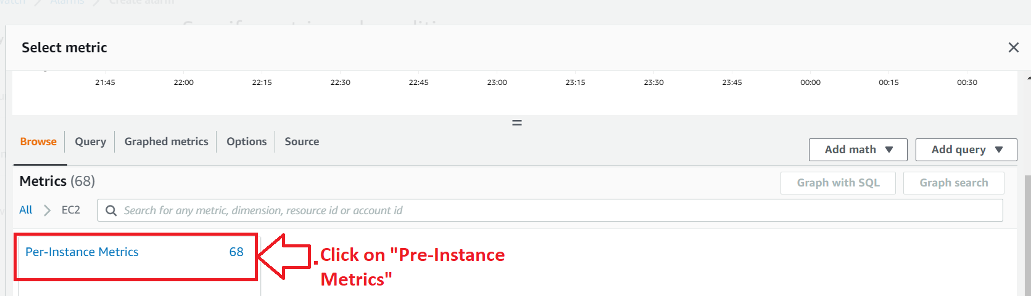

**Step 14: Choose** the **“ec2”** as **“CPUUtilization”. Click** onthe **“Select metric”.**

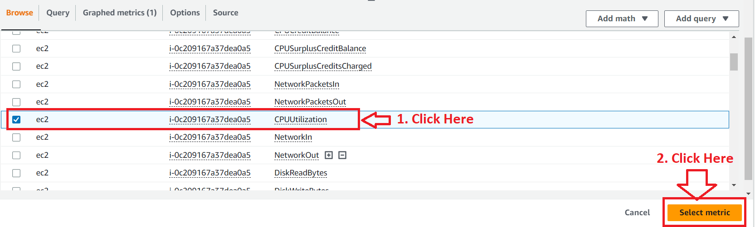

**Step 15: Put** the **EC2 “Instance ID”** inthe **“InstanceId” section. Copy** your **EC2 Instance ID** fromthe **“EC2 section”.**

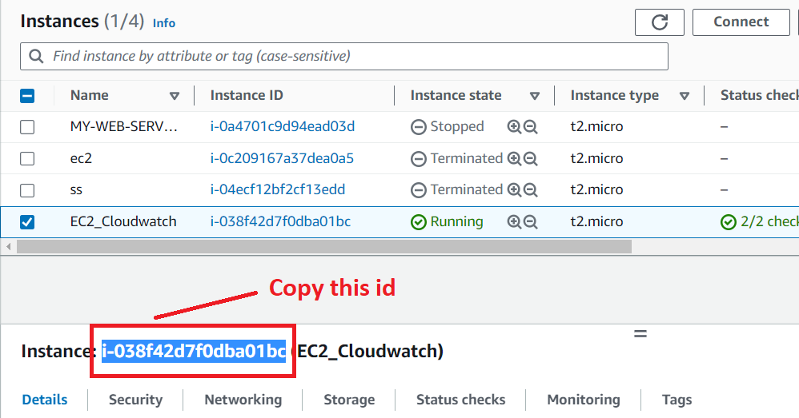

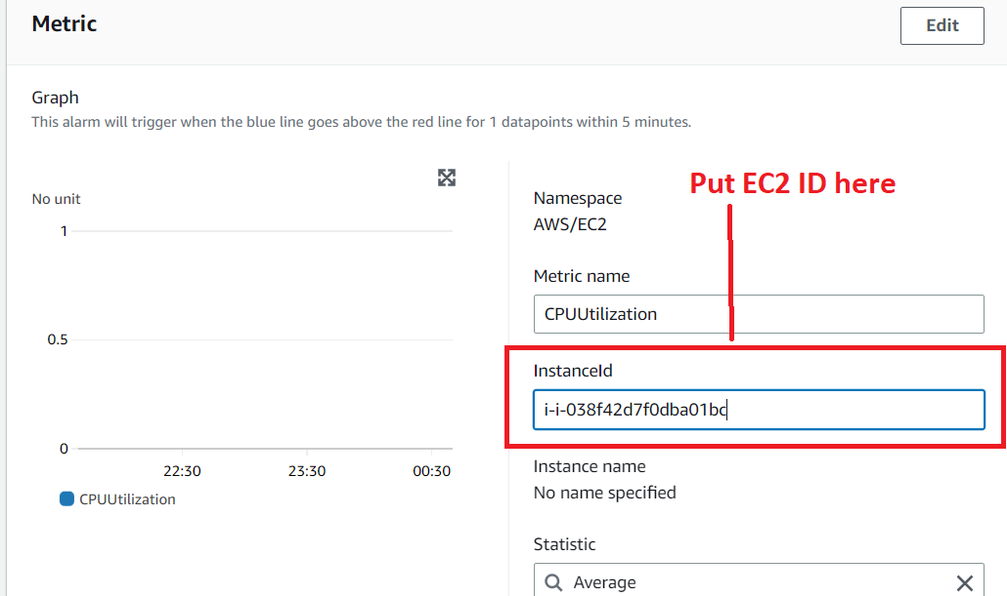

**Step 16: Choose** the **Period** 1 **“5 Minute”.**

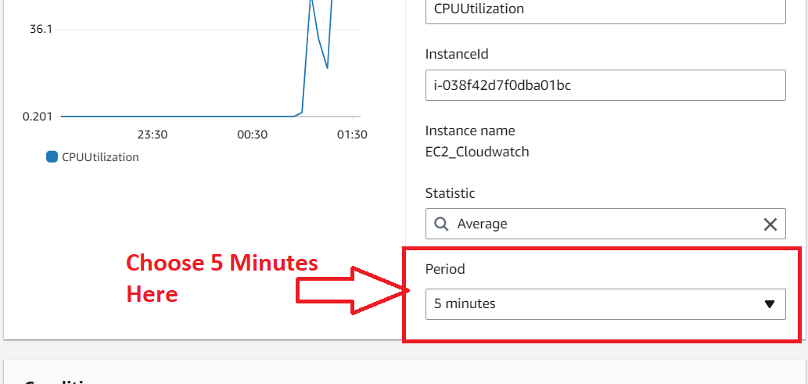

**Step 17: Choose** the **“65%”** inthe **“Define the Threshold Value”. Click** onthe **“Next”.**

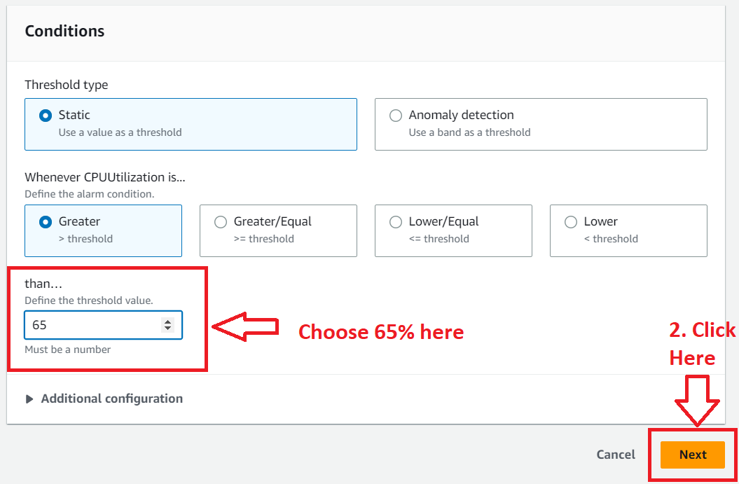

**Step 18: Go** to the **“EC2 Action”** & **click** on the **“Add EC2 Action”.**

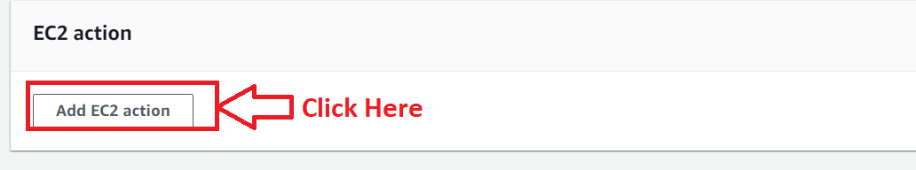

**Step 19: Choose** the **“In alarm”** asthe **“Alarm State Trigger” & choose** the **“Stop the Instance”** option inthe **“Take the following action…”** section.

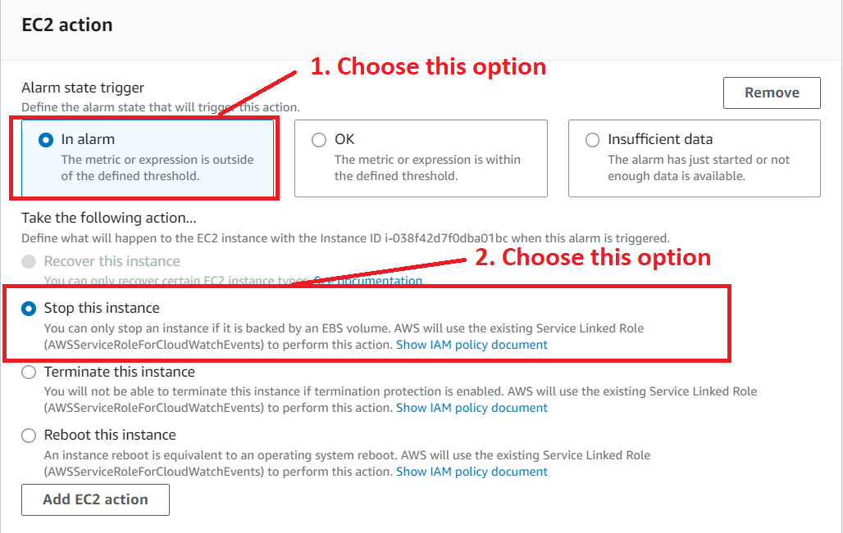

**Step 20: Click** onthe **“Next”.**

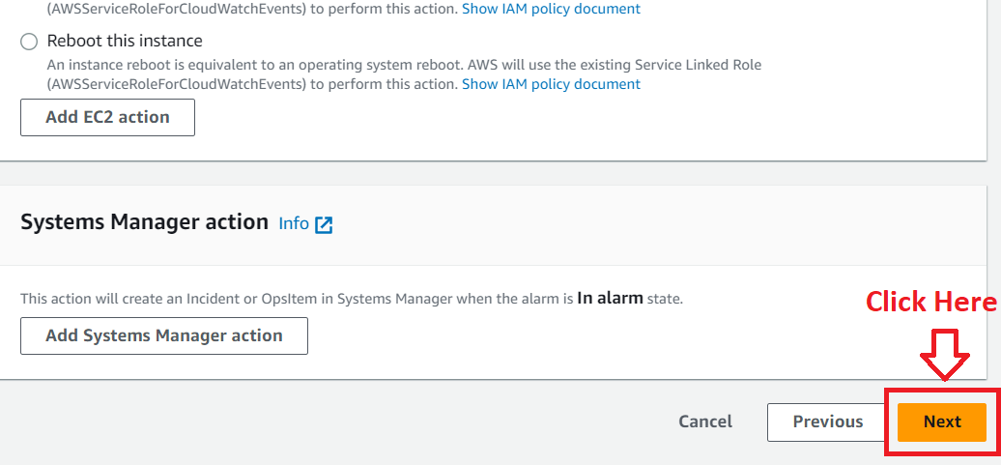

**Step 21: Choose** the **“Alarm Name”** asthe **“EC2Alarm”. Click** onthe **“Next”.**

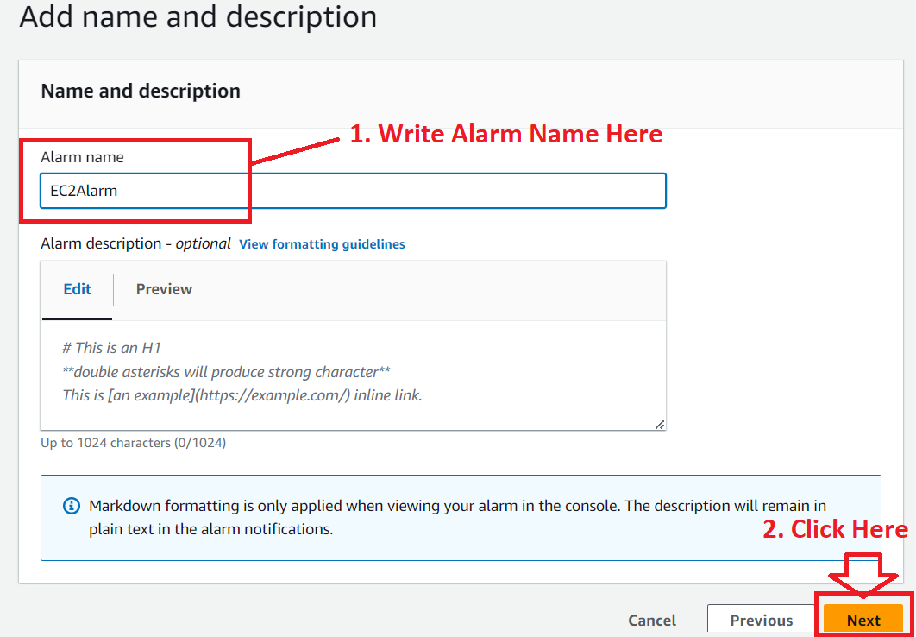

**Step 22: In** the **“Preview & Create”, you** will **review** your **alarm settings. Click** on the **“Next”.**

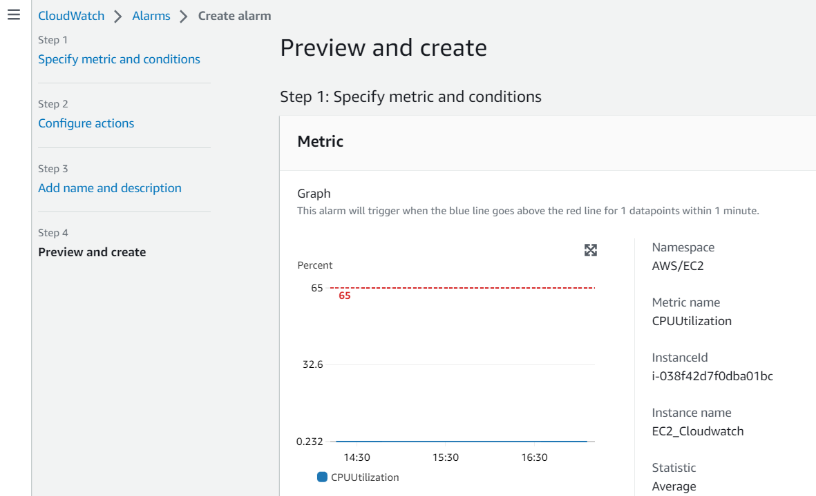

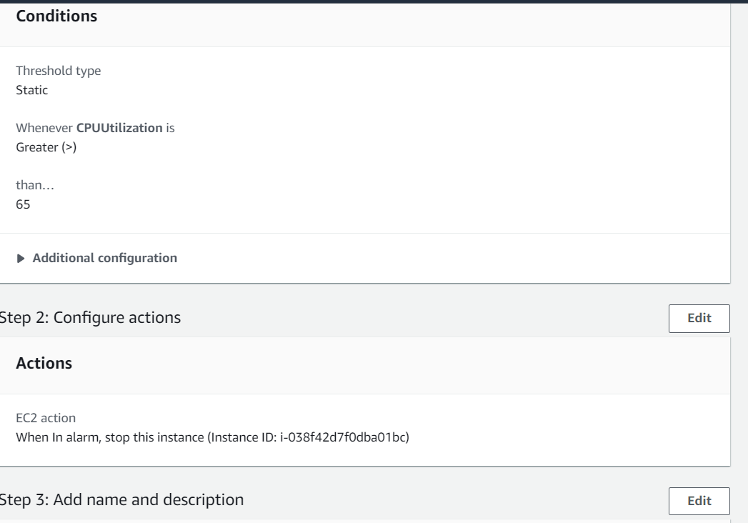

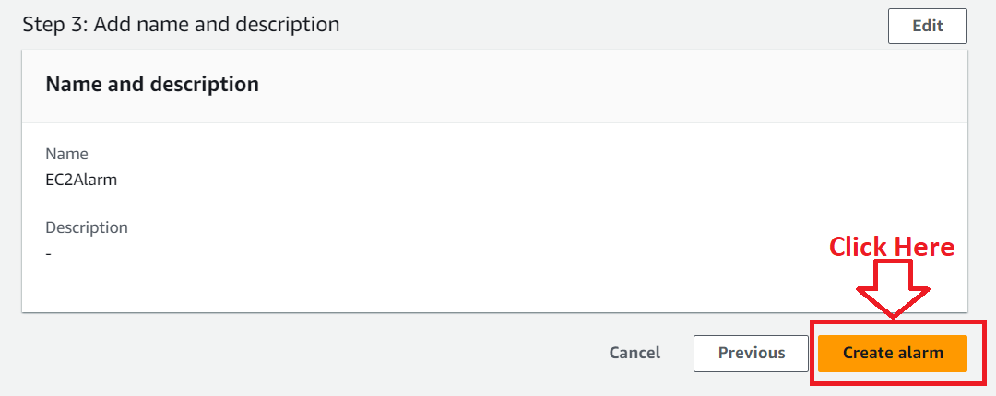

**Step 23: Your Alarm** will be **successfully created** asthe **“EC2Alarm”.**

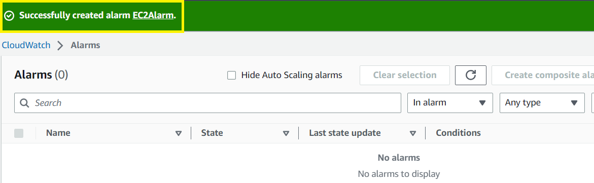

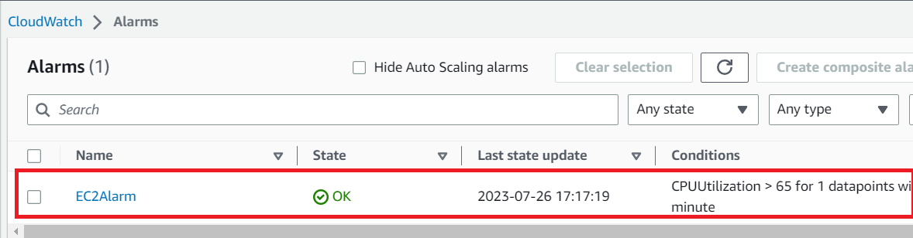

**Problem 2 (a) Solution:** Also add an SNS topic, so it notifies the person when the threshold is crossed.

**Step 1: Go** to the **Alarms** & **Click** on the **“EC2Alarm”.**

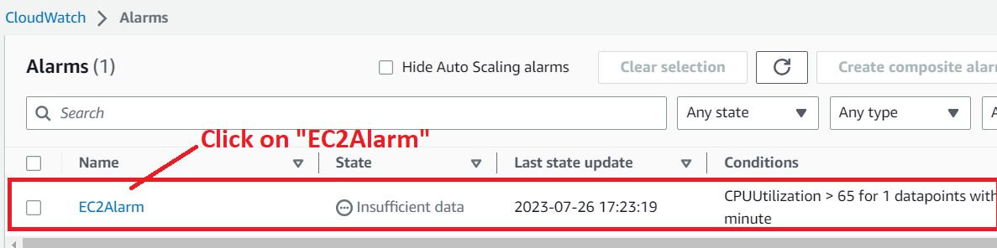

**Step 2: Go to Actions>Edit.**

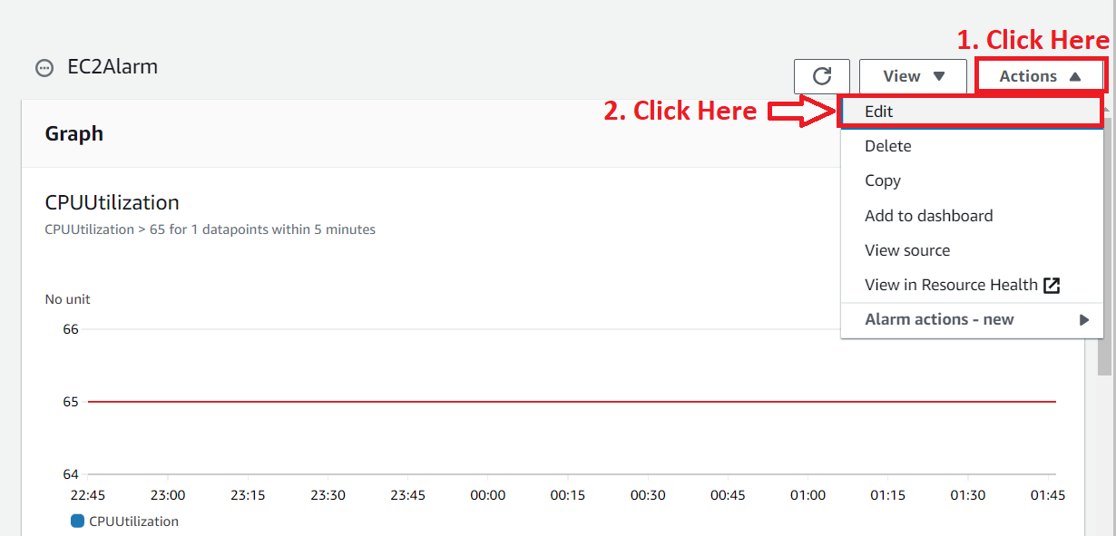

**Step 3: Go** to the **“Configure Actions”.**

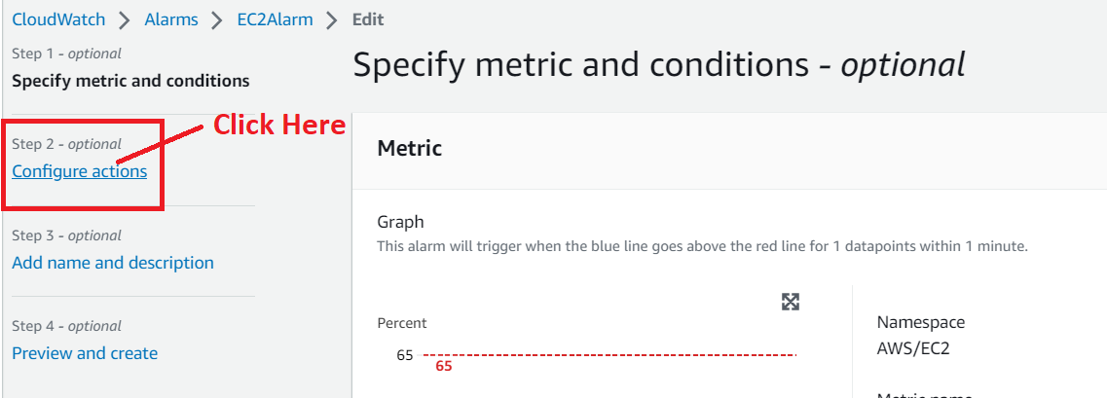

**Step 4: Go** to the **“Notifications>Add Notifications”.**

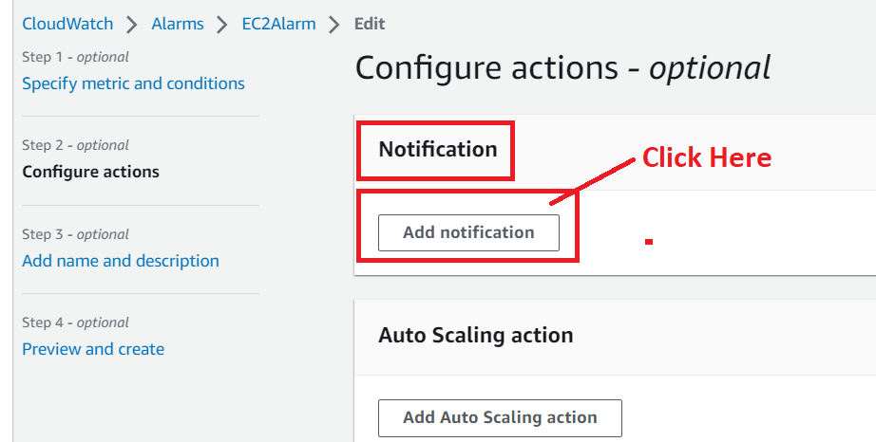

**Step 5: Choose** the **following options:**

**a. Alarm State Trigger –** In alarm

**b. Send a notification to the following SNS topic –** Create new topic

**c. Create a new topic –** EC2_Topic

**d. Email Endpoints –** [**vishal6gzb@gmail.com**](mailto:vishal6gzb@gmail.com)

**e. Click** on the “**Create topic”.**

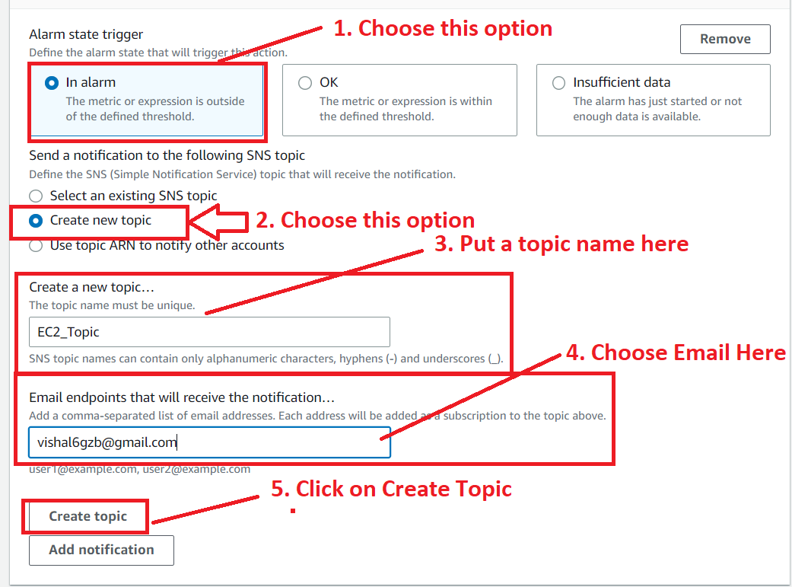

**The Topic** will be **successfully created** asthe **“EC2_Topic”** & the **“Email end point”** as the[**vishal6gzb@gmail.com**](mailto:vishal6gzb@gmail.com)

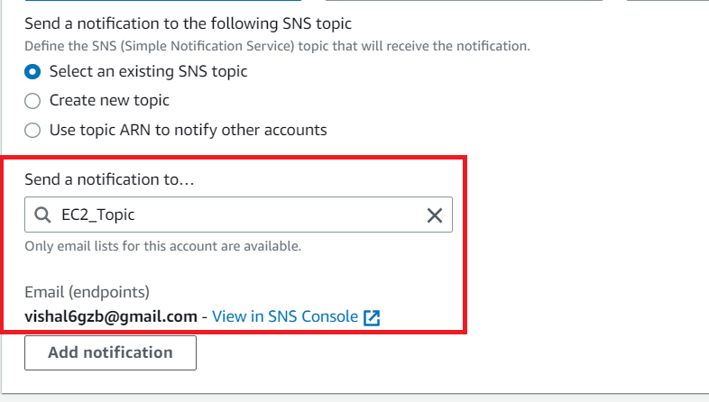

**f. Click** on the **View in SNS Console. Your topic & subscription** will be **successfully created. Now, you** must **confirm** the **subscription** through **email id. Open** the **“AWS Notification email”.**

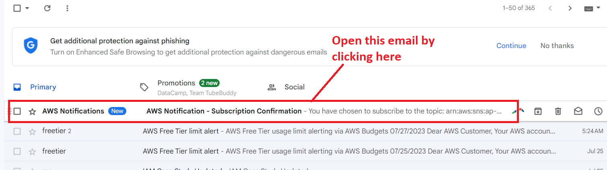

**g. Click** onthe **“Confirm Subscription”.**

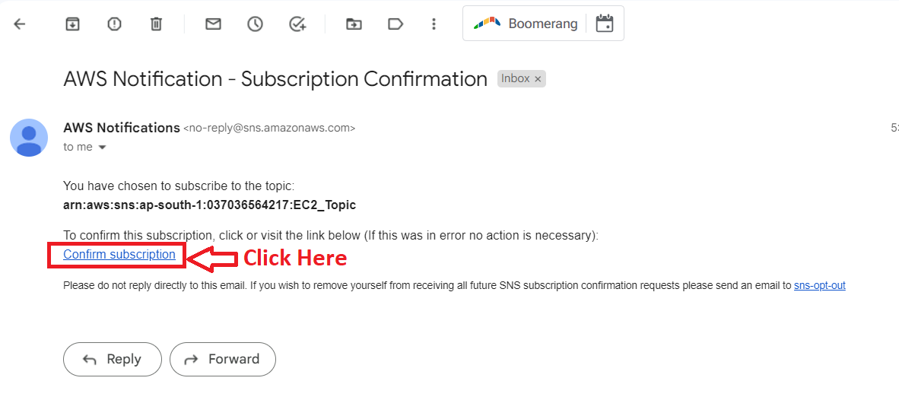

**h. You** will **get** a **“Subscription Confirmed!”** message.

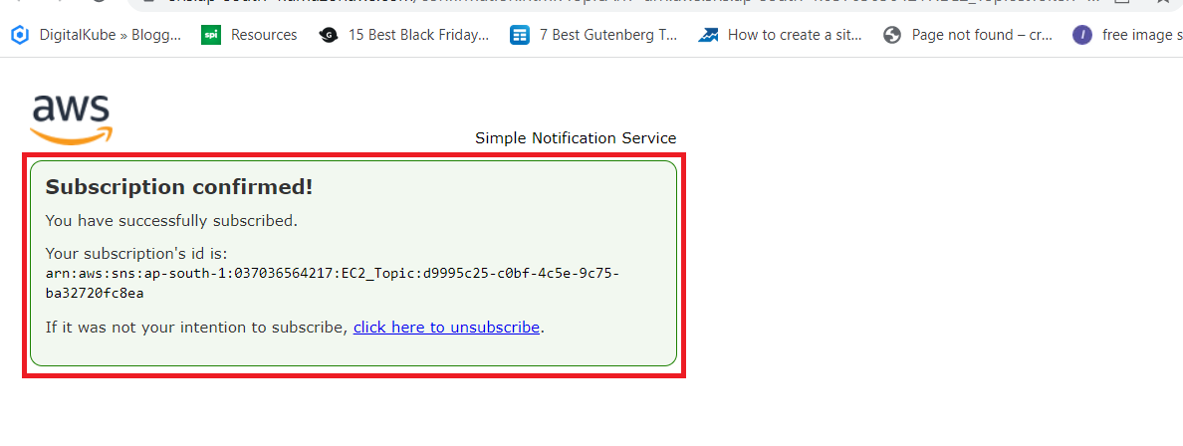

**i. Go** toyour **SNS Dashboard** & **refresh the page. You** will notice that the **“Subscription Status”** as **“Confirmed”.**

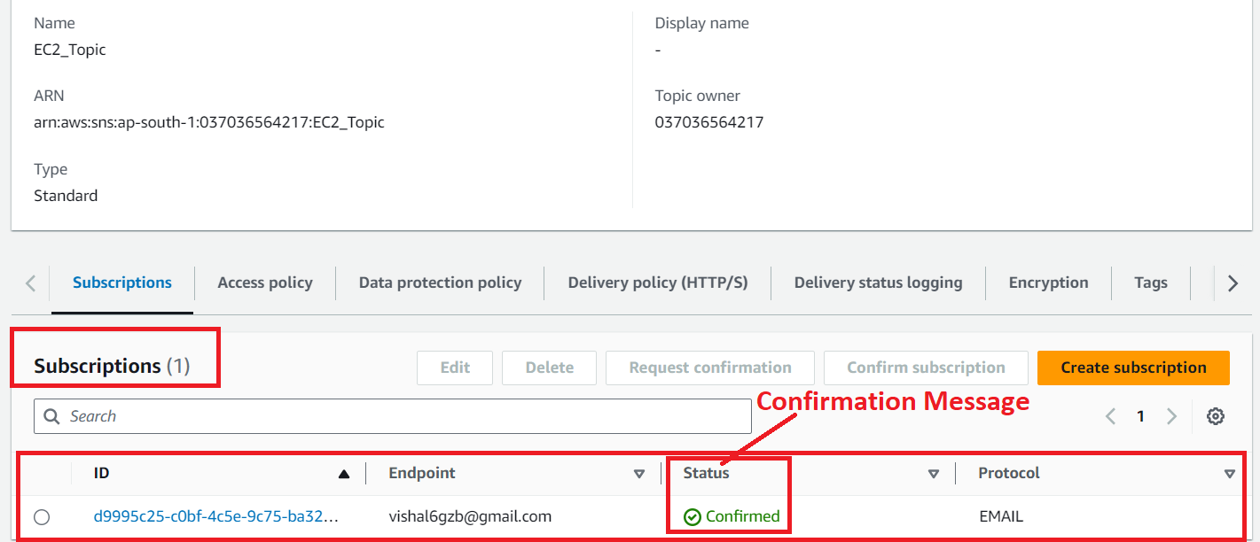

**Step 6: Go** tothe **“CloudWatch Management Console”** & **click** onthe **“Next”** in **“Configure Actions”.**

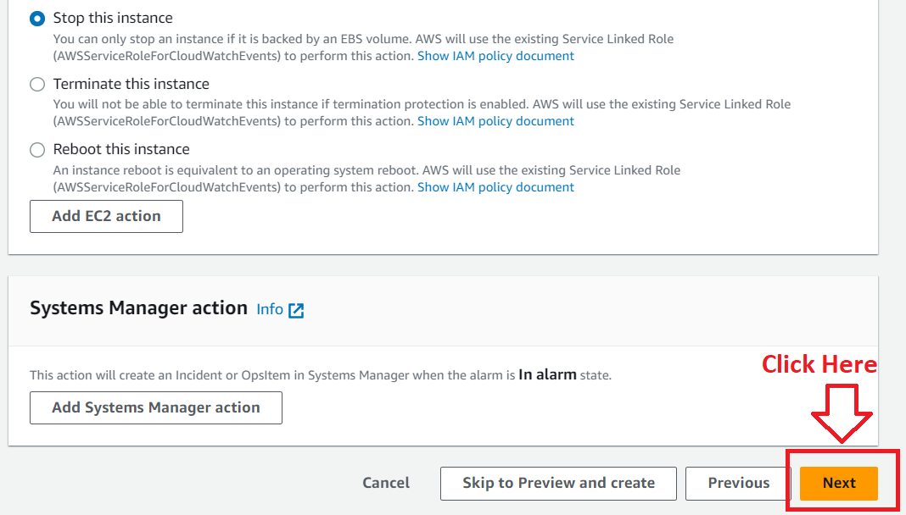

**Step 7: Again, click** on the **“Next”.**

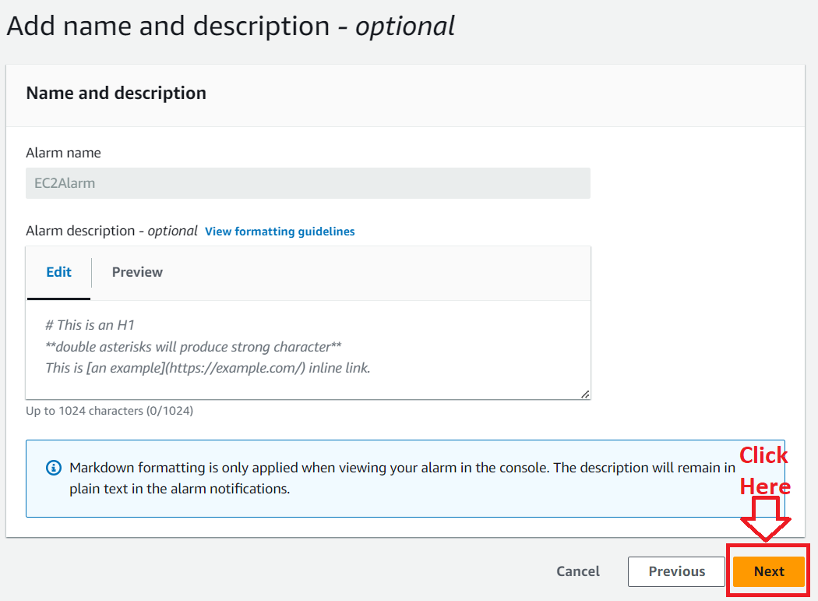

**Step 8: Click** onthe **“Update Alarm”** inthe **“Preview and create -optional”.**

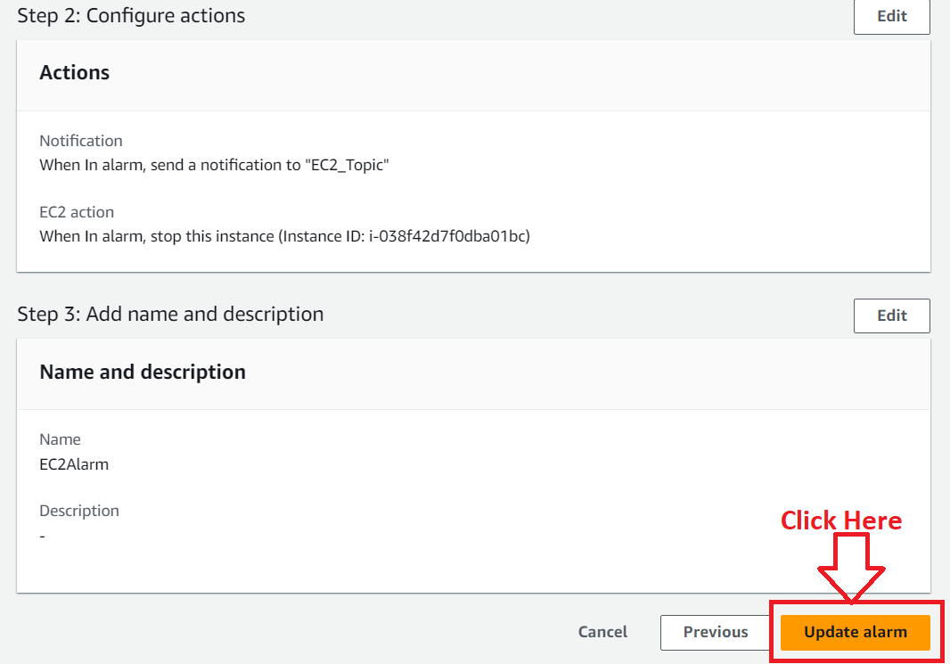

**Step 9: The alarm** will be **successfully updated** & **your SNS topic** will be **successfully created. When** your **EC2 instance exhausted** the **65% threshold, you** will **get notified** through **email id.**

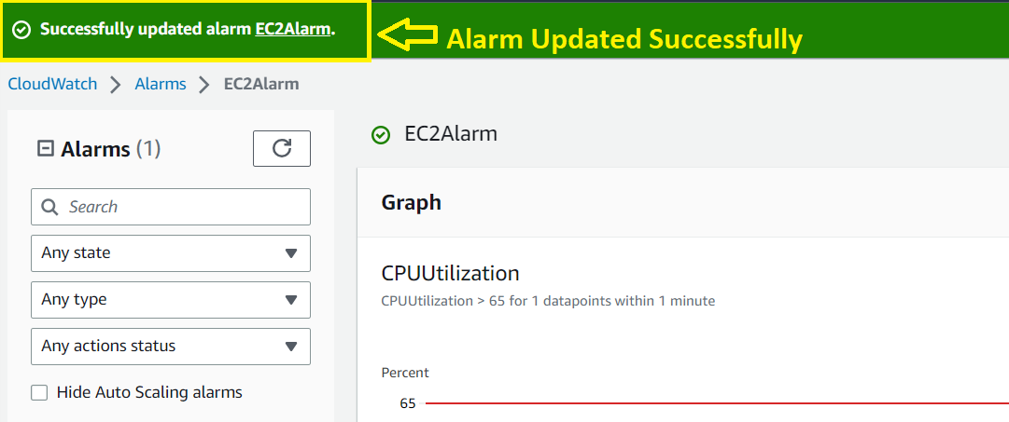

**Now, we** will **test** the **EC2 Instance** and **exhausted it. After exhaustion, it** will **go** to the **“Alarm state”** & **stop** the **instance. It** also **sends** the **notification** through **email id** also**.**

***Test EC2_CloudWatch Alarm***

**Step 1: Go** tothe **“EC2 Dashboard”** & **Select** the **EC2 Instance. Click** on the **“Connect”** button.

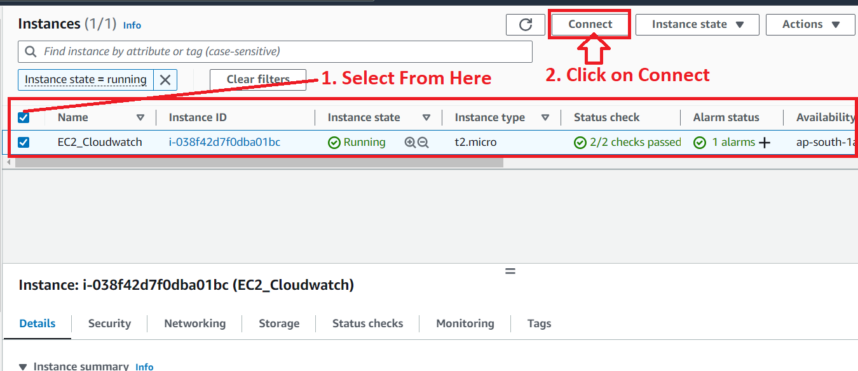

**Step 2: Go** tothe **“EC2 Instance Connect”. Click** onthe **“Connect”.**

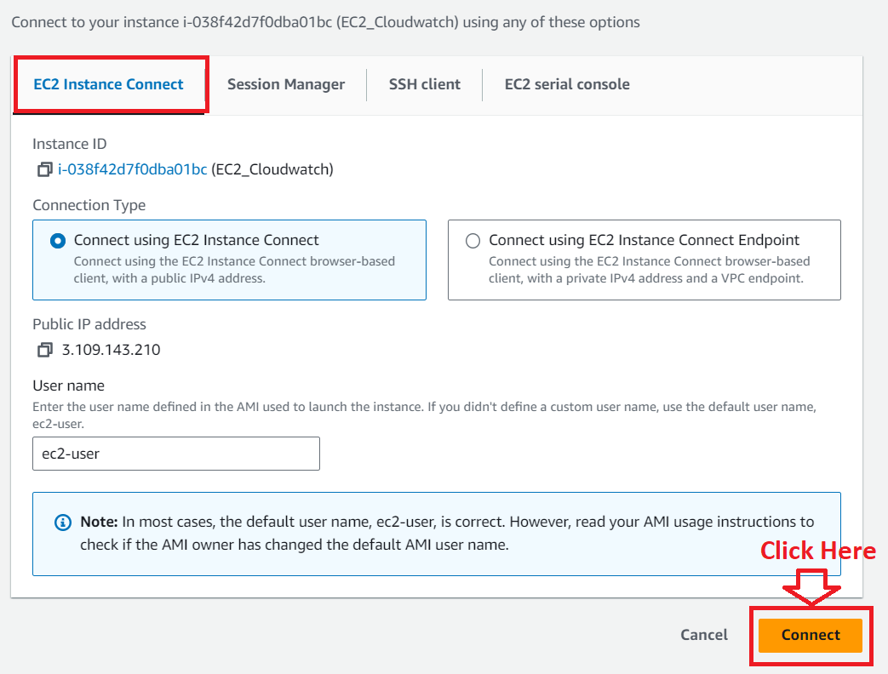

**Step 3 The “EC2 Instance Connect”** will be **opened. Perform** the **operation here, until** the **stopped condition. After running** the **heavy** script**, the EC2 instance** hasbeen **stopped.**

**Commands are:**

1. **sudo su**
2. **sysctl -w net.ipv4.tcp_tw_reuse=1**
3. **sysctl -w net.ipv4.tcp_timestamps=1**
4. **ulimit -n 250000**
5. **sysctl -w net.ipv4.ip_local_port_range=“1024 65535”**
6. **sysctl -w net.ipv4.tcp_tw_reuse=1**
7. **sysctl -w net.ipv4.tcp_timestamps=1**
8. **ulimit -n 250000**

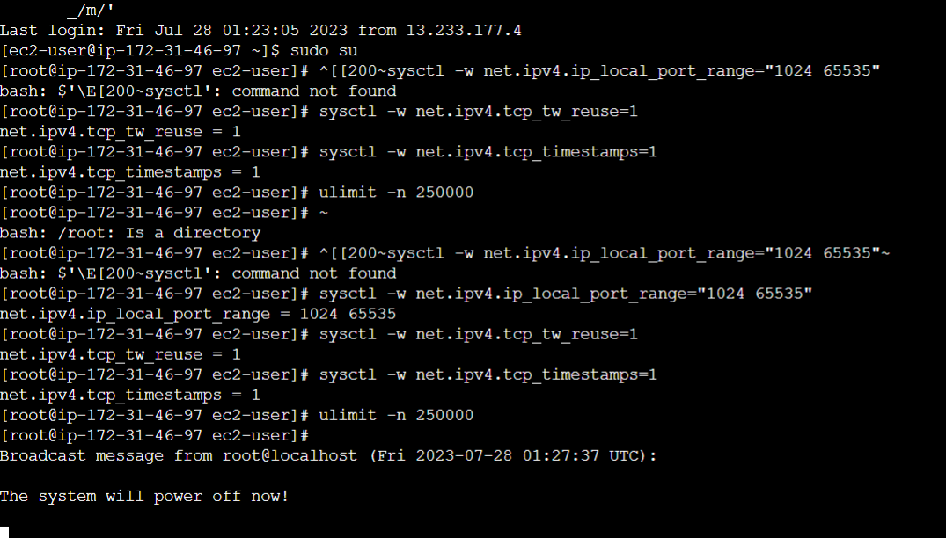

**Step 4: You** can also **watch** your **EC2 instance dashboard** & **notice** that **your EC2 instance** hasbeen **stopped** & **goes** intothe **Alarm state.**

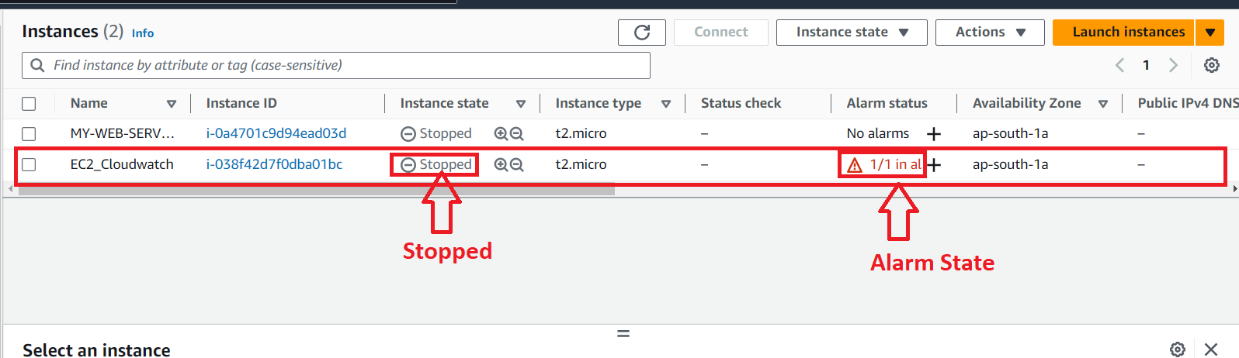

**Step 5: Go** to **the “Cloudwatch”** & **your alarm state** will be **“In Alarm”.**

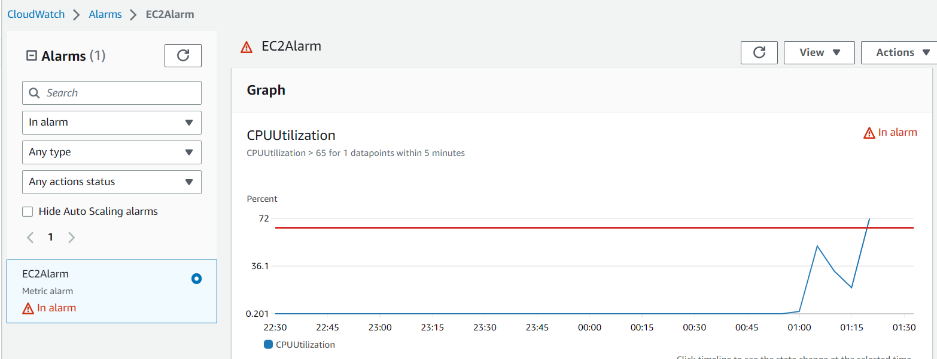

**Step 6: An email** will be **sent** to your **“Email id” & it** will **tell you** that **your alarm** will gofrom **“Ok”** to the **“Alarm state”.**

